File Creation and Role Based Permission  
  
**Task Description:**   
   
Create a file with .txt extension (/home/demo.txt). Change the permission set of that file, so that any user can read it, group can read/write & owner can read/write/execute it.  
  
  
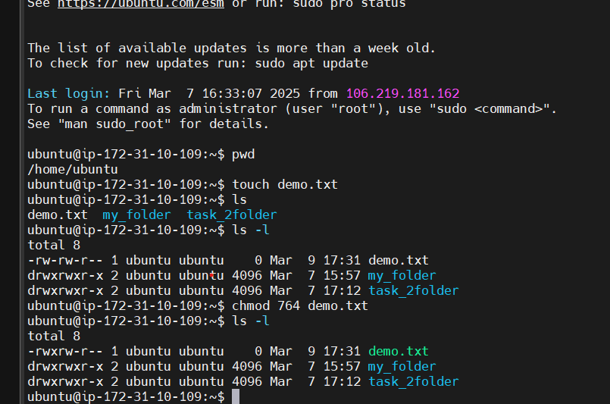  
  
  
  
  
  
Two Ways we can give permission   
  
Octal Notation: chmod 764 demo.txt  
  
Symbolic Notation: chmod u=rwx, g=rw,o=r demo.txt